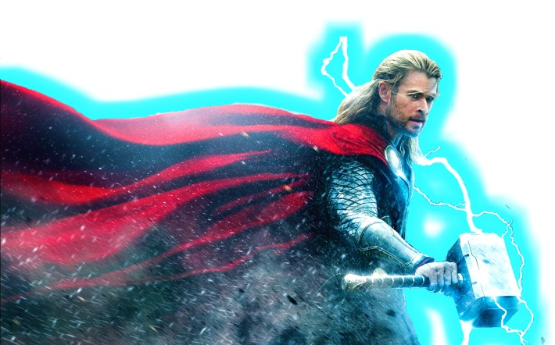  8 x 11 = |  | 7 x 6 = | Batman and Hawk-girl are defeated! Have you practiced your 6, 7 and 8 times tables enough to vanquish the terrible Thor? | 5 x 2 =
6 x 7 = |  | 6 x 12 = |  | 2 x 3 =
8 x 2 = |  | 8 x 4 = |  | 1 x 4 =
6 x 1 = |  | 6 x 3 = |  | 4 x 5 =
7 x 7 = |  | 7 x 4 = |  | 3 x 7 =
6 x 6 = |  | 6 x 11 = |  | 10 x 9 =
8 x 3 = |  | 7 x 9 = |  | 0 x 10 =
6 x 8 = |  | 8 x 10 = |  | 9 x 2 =
7 x 5 = |  | 7 x 1 = |  | 5 x 3 =
6 x 2 = |  | 6 x 9 = |  | 8 x 4 =
8 x 6 = |  | 7 x 8 = |  | 3 x 5 =
6 x 10 = |  | 8 x 8 = |  | 6 x 6 =
7 x 0 = |  | 7 x 3 = |  | 4 x 7 =
6 x 0 = |  | 8 x 1 = |  | 7 x 8 =
7 x 2 = |  | 7 x 11 = |  | 8 x 6 =
8 x 5 = |  | 6 x 4 = |  | 8 x 9 =
6 x 5 = |  | 8 x 7 = |  | 2 x 10 =
7 x 10 = |  | 7 x 12 = |  | 8 x 0 =

Your time
Time needed to beat Thor | 4 minutes 15 seconds

